**CSS Absolute Positioning**

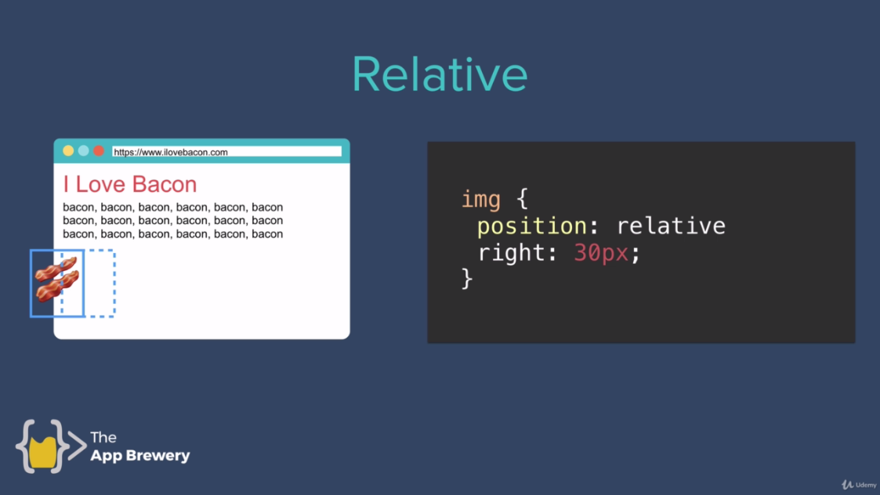

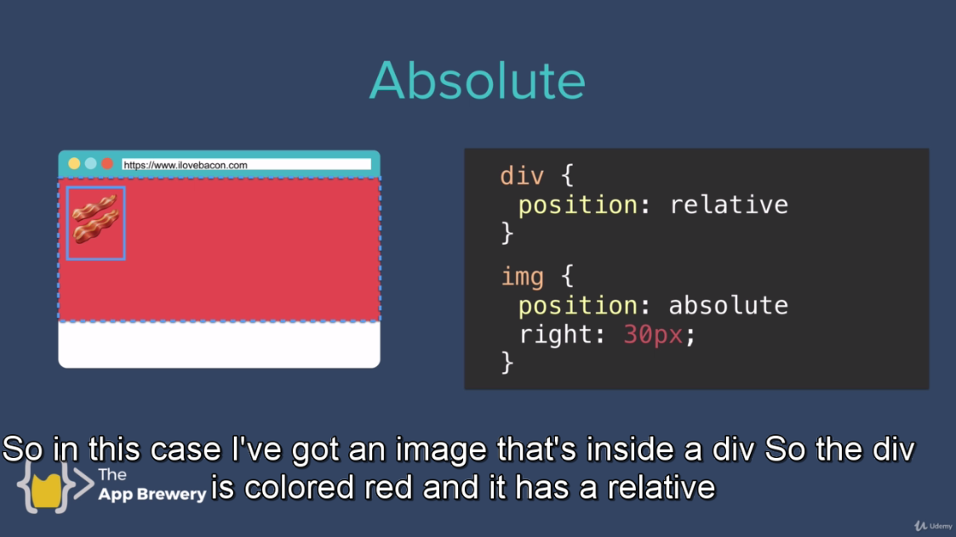

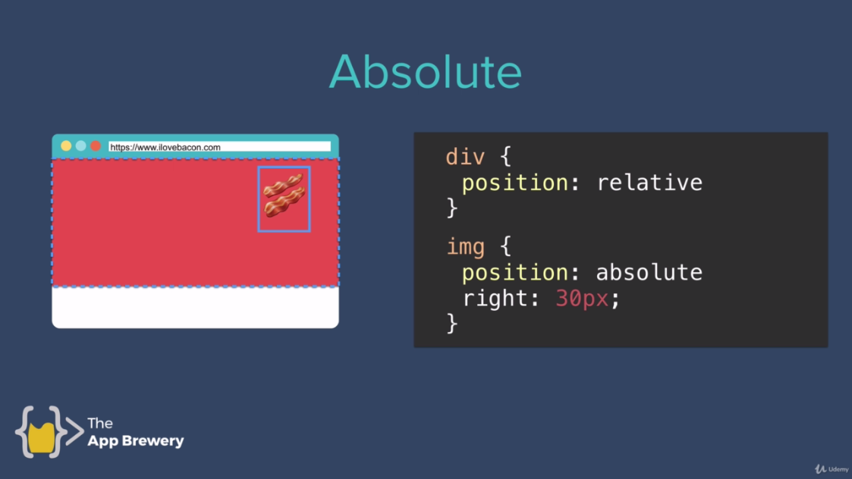

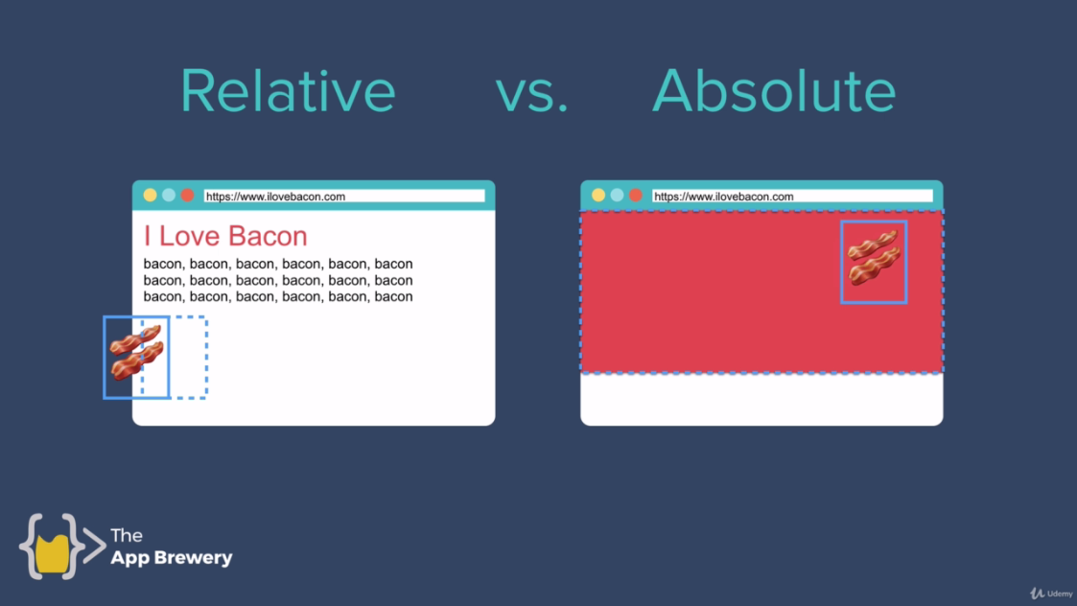

**Code:**

**Styles5.css:**

/************************* TAG SELECTORS ***********************/

body{

margin: 0;

}

/************************* CLASS SELECTORS ***********************/

.red{

background-color: red;

height: 100px;

width: 100px;

position: absolute;

left: 300px;

/* top:50px; */

/*right:50px;*/

/* bottom: 50px;/*

display: inline-block; /* to move block in line instead of top to bottom*/

}

.blue{

background-color: blue;

height: 100px;

width: 100px;

display: inline-block;

position: absolute;

top: 180px;

left: 200px;

/* right: 30px; */

}

.pink{

background-color: pink;

height: 100px;

width: 100px;

position: absolute;

top: 180px;

left: 300px;

display: inline-block;

}

.yellow{

background-color: yellow;

height: 100px;

width: 100px;

display: inline-block;

position: absolute;

top: 180px;

left: 400px;

/* right: 30px; */

}

.orange{

background-color: orange;

height: 100px;

width: 100px;

display: inline-block;

position: absolute;

top: 280px;

left: 300px;

/* right: 30px; */

}

**Index5.html:**

<!DOCTYPE html>

<html lang="en" dir="ltr">

<head>

<meta charset="utf-8">

<title>CSS Positioning</title>

<link rel="stylesheet" href="css/styles5.css">

</head>

<body>

<h1>CSS Static and Relative Positioning</h1>

<div class="red">

</div>

<div class="blue">

</div>

<div class="yellow">

</div>

<div class="pink">

</div>

<div class="orange">

</div>

</body>

</html>

***Code 2:***

**Style6.css:**

/************************* TAG SELECTORS ***********************/

body{

margin: 0;

}

/************************* CLASS SELECTORS ***********************/

.container{

width: 300px;

height: 300px;

position: relative;

background-color: grey;

}

.red{

height: 100px;

width: 100px;

background-color: red;

position: absolute;

left: 200px;

top: 100px;

/* display: inline-block; /* to move block in line instead of top to bottom*/

}

.blue{

background-color: blue;

height: 100px;

width: 100px;

display: inline-block;

position: absolute;

top: 100px;

left: 100px;

/* right: 30px; */

}

.yellow{

background-color: yellow;

height: 100px;

width: 100px;

display: inline-block;

position: fixed;

top: 100px;

/* right: 30px; */

}

**Index6.html:**

/************************* TAG SELECTORS ***********************/

body{

margin: 0;

}

/************************* CLASS SELECTORS ***********************/

.container{

width: 300px;

height: 300px;

position: relative;

background-color: grey;

}

.red{

height: 100px;

width: 100px;

background-color: red;

position: absolute;

left: 200px;

top: 100px;

/* display: inline-block; /* to move block in line instead of top to bottom*/

}

.blue{

background-color: blue;

height: 100px;

width: 100px;

display: inline-block;

position: absolute;

top: 100px;

left: 100px;

/* right: 30px; */

}

.yellow{

background-color: yellow;

height: 100px;

width: 100px;

display: inline-block;

position: fixed;

top: 100px;

/* right: 30px; */

}